

**UNIVERSITY OF PETROLEUM & ENERGY STUDIES**

**Dehradun**

**APPLICATION CONTAINERISATION**

**Name: Shivani Tyagi**

**Course: B. TECH CSE DevOps (2018-22)**

**Roll no.: R171218097**

**Sapid: 500067253**

**Experiment-2**

**Docker Volume**

**Step-1:** Check any container is running or not by **docker ps** command

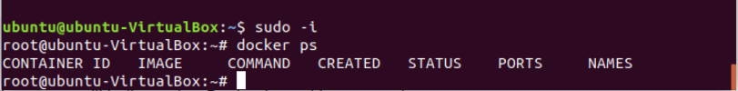

**Step-2:** Now, run a container, **con1** of **ubuntu** image with a volume named **vol**

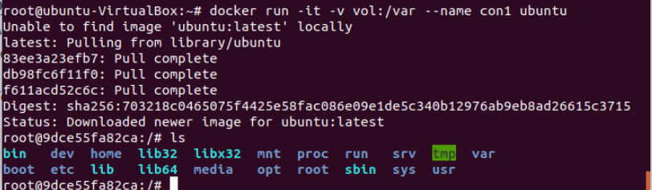

**Step-3:** Now in **var** folder create files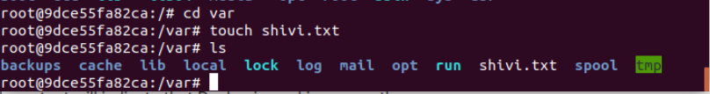

**Step-4:** Create another container, **con2** with the same volume **vol**. After creating con2, files of con1 will be displayed in con2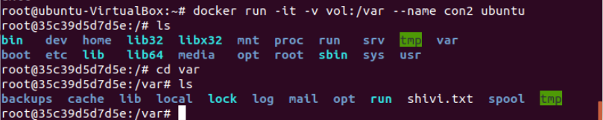

**Step-5:** Now inspect the created volume **vol**

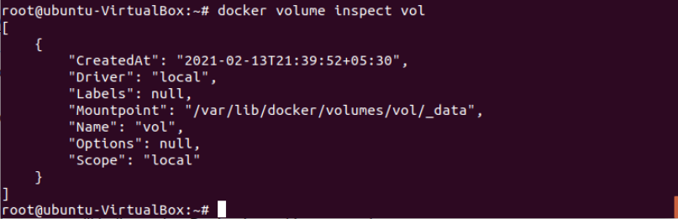

**Step-5:** Going to the location of volume and checking the created files

